**Demand**

* Method / Qualitative

1. Online Questionnaire
2. Offline Survey
3. Depth-interview

* Object Group / interviewee

1. University Students
2. Social Workers

* Quantity

1. Questionnaire & Offline Survey: received 86 valid copies
2. Interview: 3

* Depth Interview Results

1. Difficulties when you look for a mental doctor/clinic

About Hospitals

* Many hospitals have no mental services
* Few famous mental clinics in China. Mental service market is a bit messy
* Lack of mental clinic brand and mental service system
* Don't know the website entrance to the psychology service

About Doctors

* + Few information is provided
  + Many doctors do not have license
  + Don't know where to find a doctor at all
  + No comments or rating about doctors, so hard to choose

About the Market

* + Lack of regulation and management
  + Many individual mental service
  + Lack of publicity & ads for mental service

1. Difficulties when you make a reservation to see a mental doctor

About Reservation Entrance

* Do not have reservation entrance
* Need to reserve physically or call
* Hard to find the entrance

About Reservation Slots

* Lack of slots
* Because offline service takes more time than online
* Need to ask the slots when offline, cannot see by myself

1. Payment and Costs of mental consultations

Payment

* Few payment methods when offline
* Need to go to cashier when offline
* Need to take the hard copy receipt instead of an online one
* Not synchronized between offline payment and online order in time, need to wait

Costs

* It costs a lot to see a mental doctor
* Sometimes I just need some suggestions, no need to see a doctor offline
* Unclear about the charging items detail

1. Bad experience when doing mental health examination

Inconvenience

* Need to manually fill in the questionnaire with pen and wait for assessment
* Questions are answered before consultation, and it takes a long time in the mental clinic
* The process is tedious and inefficient
* Potentially, the result would lose and need to fill in again

Feedback

* The checking of the exam may be slow
* Take a long time to get the result
* Lose patience during the process

1. Bad experience when doing mental consultation

Inconvenience

* Take a long time to go to the clinic
* Makes me feel more upset

Afraid

* Fear face to face communication when talks about secrets
* Unfamiliar environments

Time

* Waste time on the way to clinics and queues
* Complex service process (reserve, schedule, sign in, payment, wait for feedback)
* Cannot see my queue number unless I am in the clinic

1. Bad experience after consultation

Feedback

* Lack of interaction with the doctors after consultation
* Suggestions and feedback are oral or in paper

Comments

* Lack of ways to share my comments
* Cannot know others’ comments

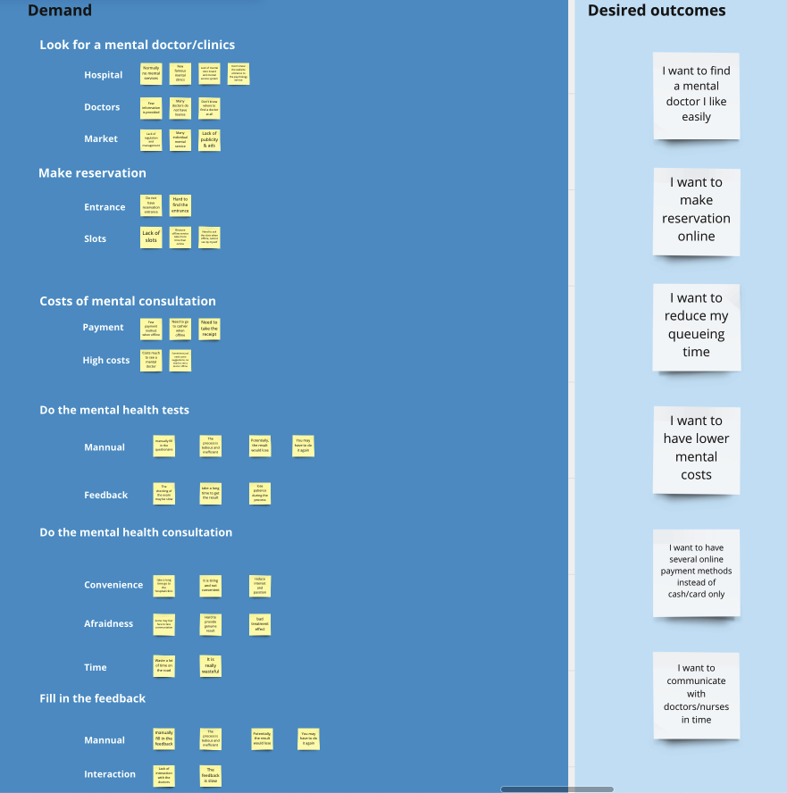

**Service**

* Method / Qualitative

1. Online Questionnaire
2. Depth-interview

* Object Group / interviewee

1. Counselor
2. Psychologist

* Quantity

1. Questionnaire: received 65 valid copies
2. Interview: 3

* Quantitative

1. Value

Question *x* | Answer *xn* |Answer *xRj_n* | Replier *Rj*

1. Ratio
2. For *Axi* in *Qx*: *Ax(i)* *Number* / *Ax**Amount*
3. For *Axi* in *Qx*: *R* *Number for* *Axi* / *Rj**Amount*
4. Weighted Average

For *Ayi* in *Qy*: SUM (*Ay (Rj_i)* Value * *Rj*Value)/ *Rj**Amount*

* Collected Questionnaire Result

1. Context

|  |  |  |
| --- | --- | --- |
| Question | Answer | Quantitative |
| Work Location | Super first-line city | 57.7% |
| First-line city | 32.3% |
| Others | 10% |
| Career Area | Teenager | 27.7% |
| Work | 26.3% |
| Emotional Relationship | 14.8% |
| Women | 13.2% |
| Marriage | 11.3% |
| Covid | 6.7% |
| Work time | < 1 year |  |
| 1~3 years |  |
| 3~5 years | Most |
| > 5 years |  |
| why choose the career | Achievement | Most |
| Interest |  |
| Responsibility |  |
| Income |  |

1. Current Experience

|  |  |  |
| --- | --- | --- |
| Question | Answer | Quantitative |
| Patients/Consultants Number per day | 1~2 | 20.3% |
| 3~5 | 60.7% |
| > 5 | 19% |
| Taken Time per person | <= 45min | 34.7% |
| 45~90min | 52.6% |
| > 90min | 12.7% |
| Patients/Consultants’ Job | Retire | 32.5% |
| Student | 26.5% |
| Commuter | 23.1% |
| Service | 10.7% |
| Individual | 7.2% |
| Patients/Consultants’ Age | < 18 | 37.4% |
| 18~24 | 28.5% |
| 25~34 | 24.1% |
| 35~44 | 6.2% |
| > 44 | 3.4% |
| Service Channel | Mental Hospital / Clinic | 60.3% |
| Online | 21.9% |
| Comprehensive Hospital | 15.9% |
| Home | 1.9% |
| Current Difficulties | Insufficient customer resources | 1st |
| Covid Impact / Epidemic Control Policy | 2nd |
| Geographic restrictions | 3rd |
| Tight Schedule | 4th |
| Mental Healthcare Advanced Cities | Super first-line city | 100% |
| First-line city | 32.3% |
| New first-line city | 10% |

(3) Ideal Experience

|  |  |  |
| --- | --- | --- |
| Question | Answer | Quantitative |
| Promotion Methods | Social Media | 1st |
| Shooting short videos | 2nd |
| Provide more free counseling | 3rd |
| Government Promotion |  |
| Community Talk |  |
| Train more counselors and Psychologists |  |
| View of Online Consultation | Insufficient Contact | Drawbacks |
| Inaccurate Diagnosis |
| Cannot conduct physical treatment |
| Cannot get a full picture of their condition |
| Inability to take effective action when the patient develops abnormalities |
| Uncertain degree of efficacy of treatment |
| Get rid of geographic restrictions | Profits |
| More flexible timetable |
| Prevent from Covid |

(4) Conclusion

|  |  |  |
| --- | --- | --- |
| Question | Answer | Quantitative |
| The Profits of Mental Healthcare Promotion | Better Industry Situation | 1st |
| Better Work Environment | 2nd |
| More Customer | 3rd |
| Higher Income | 4th |
| More Working Experience |  |
| Better Academic Environment |  |

* Depth-interview record

1. How do you feel about online consultation?

Pro

* Convenient
* Flexible
* out of region restriction (especially for patients)

Con

* + can’t see whole person, mostly face
  + connection issues
  + manage patients’ situation when they are present, like some extreme cases
  + judge patients’ situation face-to-face
  + difficult to deal with children's cases
  + can’t validate AR technology have same impact to value patients’ mental situation
  + can’t make sure patients have safe and personal place to have online consultation
  + Can't make patients online, they can leave Zoom anytime
  + Patients may cheat when they are answering questions
  + Can’t ensure patients’ emotional safety

1. How to make a reservation for psychological counseling? How often?

* part-time
* high demand in Singapore
* must wait for a long time to make an appointment (like 3-6 months)
* can’t make sure which group of people have the highest demand
* Once the hospital or clinic takes the patient in, the patient would see the doctor regularly to have consultation after that

1. How about the Price of psychological counseling (online & offline)? Payment means?

* Online: pay beforehand, then get the zoom link
* same price for online and offline

1. The unique features of offline?

* Personal chat room/toys
* One way mirror to observe
* Assessments involved (physical activities)

